Title: Arial, 16 pt, bold
Shigeki Kiyonaka¹, Itaru Hamachi² (Arial, 12pt; presenting author underlined)
¹Department1, Institution1, ²Department2, Institution2 (Times New Roman, 10pt, italic)
e-mail: abcdef@sbchem.kyoto-u.ac.jp (only for the presenting author)

ABSTRACT Abstract is… (Times New Roman, 10pt, bold, one column)

Main text is… (Times New Roman, 10pt, justified, single spaced, two columns)
- Put single line spacing between abstract and main text.
- The main text including abstract must not exceed one A/4 page.
- Graphics may be included, as well as references.
Graphic files: Paste your graphics, figures and formulas directly into the text body, preferably as a bitmap. Only black-and-white graphics will be accepted.
References: Indicate as consecutive numbers placed in square brackets, e.g. [1] and [2,3], etc., and referenced as in the example below.
Please send this file to ISBC2017 office using the following e-mail address:
isbc2017@sbchem.kyoto-u.ac.jp

The file must be named according to the following example:
Abstract Format (Hamachi)

Main text might not include sections such as introduction, results, discussion, and conclusion.
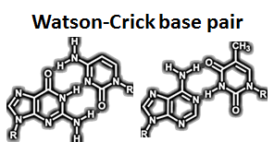
Figure 1. Caption. (Times New Roman, 9 pt)
ACKNOWLEDGEMENT
If any (Times New Roman, 10 pt)

REFERENCES
[1] A. Name, B. Name, C. Name, J. Title Abbrev., volume, first page (year).
[2] Times New Roman 10pt, single line spacing.

